- Overview of Greek Theatre
- Name the Four areas of Greek Theatre we are talking about today?
- ________________________
- ________________________
- ________________________
- ________________________
- The Land
- What two major land features make up Greece?___________________ _________________________
- What is a Patriarchal Society?____________________________
- Name three Greek Philosophers? _______________________ _____________________ _____________________
- The Land
What is the capital of Greece?____________
What directions is Mt. Olympus from Athens?____________
What Sea is Greece located east of ?_____________________
- The Land
- What are surrounding the theatre in the picture?____________
- Why would the Greeks built the theatre in this area?_________________________________
- What is the center area called?________________________________
- What was the section we just covered about?____________________________________
- What is the major land forms in Greece?___________________________________
- How were they used all over Greece?___________________________________
- What is the name of this sections?
- ____________________________
- What type of theatre did Greeks use?
- ______________________________
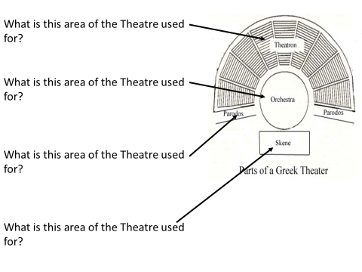
- What is wrong with these picture, from a early Greek perspective?_____________________________________

The Stage
- Who most likely would have built this Theatre?________________________
- What are the performers in the Orchestra called?_________________
- How many doors does the Skene have?
- _____________________________
- The Stage
- Greek plays were performed _________________ ____________________________________held in honor of _________________________________ ____________________________________________ (altars generally on stage)
- ____________________________________for days, people would travel from all around to see ____________________________________________prisoners were temporarily released to see the plays
- Tragedy means “_________________________” (relates to Dionysian rituals)
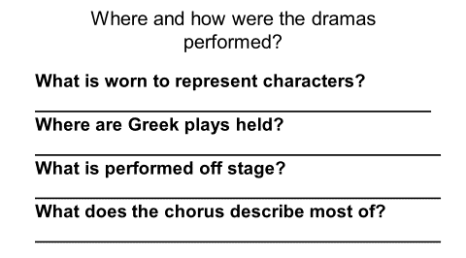
- The Dying and Rising God. Because crops die in winter and return in spring, Dionysus was seen as a symbol of ___________________________. In another story about his birth, Dionysus was the son of Zeus and Demeter, the goddess ________________ ________________. Hera was jealous of the child and convinced the Titans to destroy him. Although Dionysus was disguised as a __________________, the Titans found him, caught him, and tore him to pieces. They ate all of his body except his _________ , which was rescued by Athena *. She gave the heart to Zeus, who gave it to Semele to eat. Semele later ___________________________________. The story represents the ____________ (Demeter) and ___________ (Zeus) giving birth to the _________ (Dionysus), which die each winter and are reborn again in the spring.

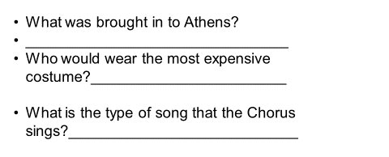
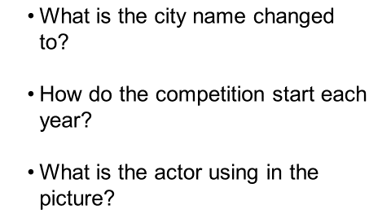
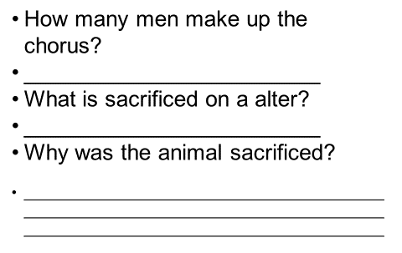
- Who is known as the first actor?___________________________________
- Who sings the Strophe and Antistrophe? __________________________________________________________
- Where does the word Thespian come from?________________________________________________________

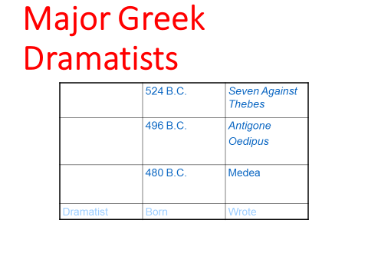
What was Aeschylus known as? ___________________________________
What did Aeschylus do according to Aeschylus?___________________________
How did he died?____________________________________________________________
- Sophocles
- What is his best known Trilogy named?_____________________________________________
- What is the name of the king and his Daughter in the trilogy?_________________________________________
- Euripides
- How did Euripides shock his audience when he wrote Medea?__________________________________
- What is Aristotle’s Poetics?________________________________________________________________
- What are the 3 parts of the Complication For Oedipus Rex?______________________________ __________________________________ _____________________________________________
- What are the 3 parts of the Unraveling for Oedipus Rex? ___________________________--________________________________________----______________________________________
- ___________________________________- serious drama featuring a noble dignified character-often a member of royalty-who strives to achieve something and is ultimately defeated
- ___________________________________ - character flaw or weakness that results in the character's downfall (usually pride/hubris)
- what are the 4 uses of the chorus?
- 1.
- 2.
- 3.
- 4.
- ___________________________ - A character, usually of high birth, neither totally good nor totally evil, whose downfall is brought about by some weakness or error in judgement
- _________________________________________________ - A tragic flaw, weakness of character or error in judgement that causes downfall in hero
- _______________________________ - Arrogance or overreaching pride which causes hero's transgression against gods; usually tragic flaw
- _________________________ - A reversal of fortune
- ____________________________________________ - Fate that cannot be escaped (Antigone)
- ________________________________ - Purgation of emotions of pity and fear which leaves the viewer both relieved and elated
- __________________________________ - recognition or discovery on the part of the hero; change from ignorance to knowledge
- The structure of Greek tragedy is characterized by
- ___________________________________
- then _____________________________________or entrance of the choirs
- Next the story unfolds through three or more____________________________________
- scattered by the stasima, choral song explaining or commenting on the situation developing in the play
- The tragedy ends with the exodus, concluding the story.

