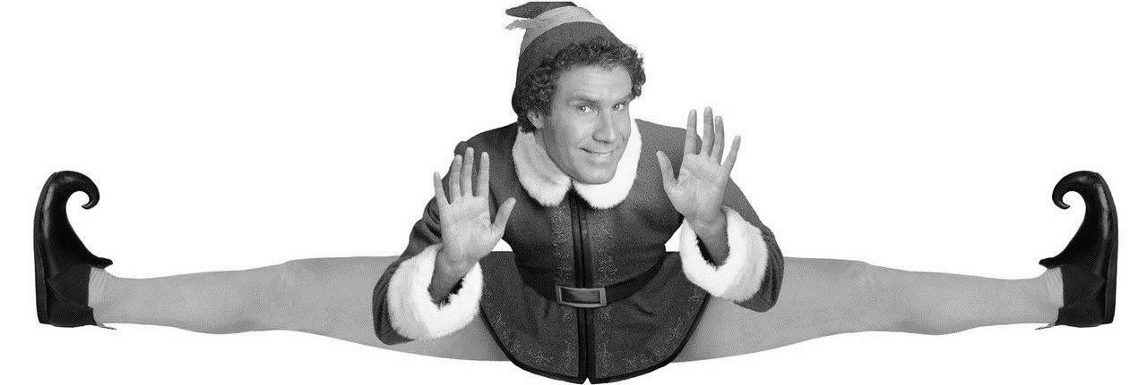
ELF The Movie and Save the Cat Structure

Opening Image – A visual that represents the struggle & tone of the story. A snapshot of the main character’s problem, before the adventure begins.
- Are fairy tales real?
- Why are elves special?
- Where does the baby live at the beginning of the show?
- What is the beginning scenes telling the audience about Santa?
- What gets into Santa’s Bag?
- Why doesn’t Santa take the baby back?
- Who says that they want to take care of the baby?
Set-up – Expand on the “before” snapshot. Present the main character’s world as it is, and what is missing in their life.
- How is Buddy different then Papa Elf?
- Does Buddy want to fit in and like the ways of being an Elf?
- Does Buddy want to grow up and be like Papa Elf?

Theme Stated (happens during the Set-up) – What your story is about; the message, the truth. Usually, it is spoken to the main character or in their presence, but they don’t understand the truth…not until they have some personal experience and context to support it.
- Is Buddy helpful and friendly to the elves?
- How is Buddy at making toys?
- How does buddy find out that he is not an elf?
- Name one way that buddy is different from the others?
- How does Buddy handle the news?
Catalyst – The moment where life as it is changes. It is the telegram, the act of catching your loved-one cheating, allowing a monster onboard the ship, meeting the true love of your life, etc. The “before” world is no more, change is underway.
- Who does Papa Elf say is Bubby’s parents?
- What does Buddy find out about his father?
Debate – But change is scary and for a moment, or a brief number of moments, the main character doubts the journey they must take. Can I face this challenge? Do I have what it takes? Should I go at all? It is the last chance for the hero to chicken out.
- What does the snowman tell him about the world?
- What does Santa tell buddy about New York?
- Who is on the Naughty list?
Break Into Two (Choosing Act Two) – The main character makes a choice and the journey begins. We leave the “Thesis” world and enter the upside-down, opposite world of Act Two.
- How does Buddy start his journey?
- Does Buddy stop acting like an Elf to blend in?
- What are some of the things that Buddy experiences in New York?
- Where does Buddy end his journey in New York that he sees in his snow globe?
- How does Walter take the news that he has a son?
- How does this new world treat Bubby?
- What does the normal people think of Buddy when he acts like an Elf?
B Story – This is when there’s a discussion about the Theme – the nugget of truth. Usually, this discussion is between the main character and the love interest. So, the B Story is usually called the “love story”.
- Does Jovie like Buddy the first time they meet?
- What does Buddy have that Jovie do not?
- Does Walter have the Christmas Spirit?
- What does Buddy think of Jovie singing voice?
The Promise of the Premise – This is when Craig Thompson’s relationship with Raina blooms, when Indiana Jones tries to beat the Nazis to the Lost Ark, when the detective finds the most clues and dodges the most bullets. This is when the main character explores the new world and the audience is entertained by the premise they have been promised.
- What does Fake Santa smell like?
- Although Walter bails him out how does Walter feel about Buddy?
- What does Walter find out at the Doctor?
- What is the main ingredient in the four basic food groups?
Midpoint – Dependent upon the story, this moment is when everything is “great” or everything is “awful”. The main character either gets everything they think they want (“great”) or doesn’t get what they think they want at all (“awful”). But not everything we think we want is what we actually need in the end.
- Who does Buddy move in with?
- Is Walter’s family excepting of Buddy’s elf ways?
Bad Guys Close In – Doubt, jealousy, fear, foes both physical and emotional regroup to defeat the main character’s goal, and the main character’s “great”/“awful” situation disintegrates.
- Who comes to Walter’s office and threatened Christmas?
- What do Buddy and his Bother encounter in the park?
- How does buddy save the day with his elf skills?
- What is all that Walter cares about?
- How does Buddy come to work?
- Where does Walter send Buddy to get rid of him?
- How do the writers decide to make a better book and save Christmas?
- What happens in the mailroom that gets Buddy in trouble?
- How does Buddy win over Jovie on their date?
- What does Buddy think Miles is because of his height?
All is Lost – The opposite moment from the Midpoint: “awful”/“great”. The moment that the main character realizes they’ve lost everything they gained, or everything they now have has no meaning. The initial goal now looks even more impossible than before. And here, something or someone dies. It can be physical or emotional, but the death of something old makes way for something new to be born.
- How does Walter act after Buddy runs Miles off?
Dark Night of the Soul – The main character hits bottom, and wallows in hopelessness. The Why hast thou forsaken me, Lord? moment. Mourning the loss of what has “died” – the dream, the goal, the mentor character, the love of your life, etc. But, you must fall completely before you can pick yourself back up and try again.
- What does Buddy tell his family when he is up-set about what Walter said?
- What do Walter do when Michael tells him Buddy is missing?
Break Into Three (Choosing Act Three) – Thanks to a fresh idea, new inspiration, or last-minute Thematic advice from the B Story (usually the love interest), the main character chooses to try again.
- Who does buddy see on the bridge at his saddest moment?
- What does Walter tell Buddy in the park?
- What scary police force is in the park looking for Santa?
- What happens when Michael believes in Santa?
- How does Michael help people believe?
- What Elf Rule does Jovie feel will help spread Christmas cheer?
Finale – This time around, the main character incorporates the Theme – the nugget of truth that now makes sense to them – into their fight for the goal because they have experience from the A Story and context from the B Story. Act Three is about Synthesis!
- How finds his Christmas spirit and saves santa getting him off the naughty list?
Final Image – opposite of Opening Image, proving, visually, that a change has occurred within the character.
- Who is singing loud for all to hear?
- Who starts his own publishing company?
- What does Buddy and Jovie have they bring to share with Papa Elf?

